WORKSHEET
Grade: I
Name: _________________
Subject: English

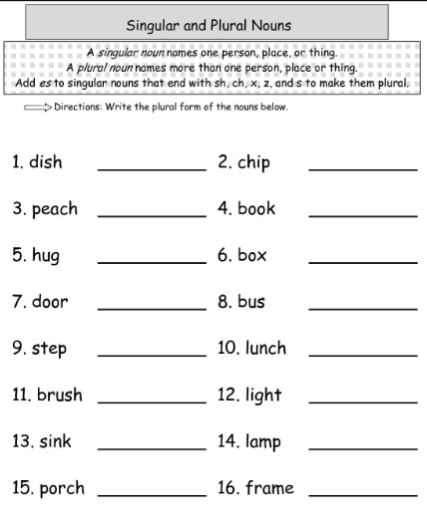

II.Write the Plural form.

